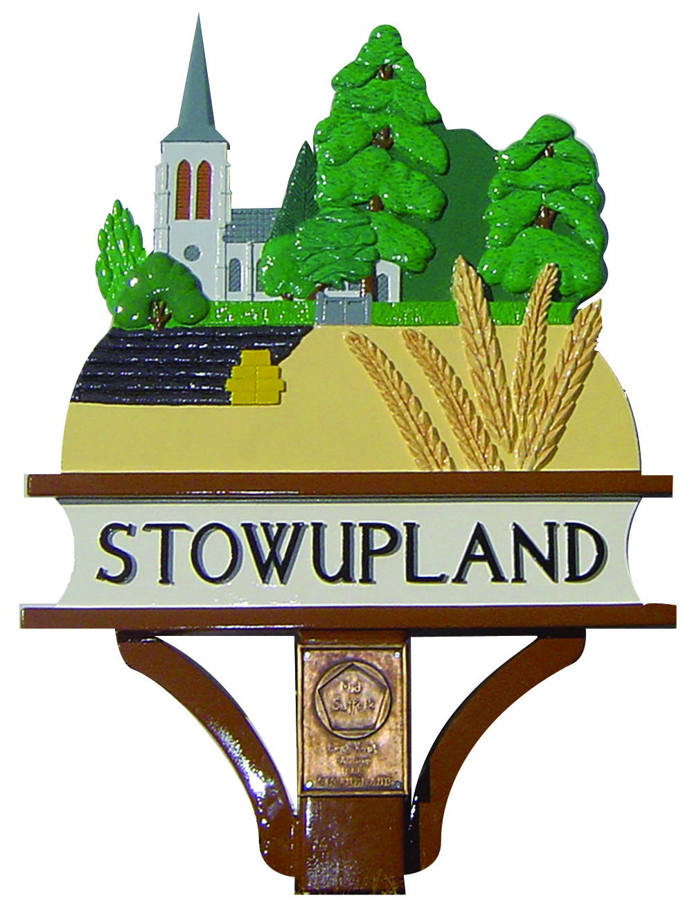

STOWUPLAND PARISH COUNCIL
2 Broomspath Road, Stowupland, Suffolk, IP14 4DB
Clerk: Claire Pizzey
01449 677005 (10am-noon Tuesdays-Thursdays)
clairepizzey@outlook.com

Grievance Procedure
Adopted 12 June 2014

Policy statement

It is our policy to ensure that all employees and councillors have access to a procedure to help deal with any grievances relating to their employment fairly and without unreasonable delay. We aim to investigate any formal grievance you raise, hold a meeting to discuss it with you, inform you in writing of the outcome, and give you a right of appeal if you are not satisfied.

Issues that may cause grievances include:

terms and conditions of employment;

health and safety;

work relations;

bullying and harassment;

new working practices;

working environment;

organisational change; and

discrimination.

This procedure does not form part of any employee's contract of employment. It may be amended at any time and we may depart from it depending on the circumstances of any case.

Who is covered by the procedure?
This procedure applies to all councillors and all employees regardless of length of service.

Using this procedure

If you have difficulty at any stage of the Grievance Procedure because of a disability or because English is not your first language, you should discuss the situation with the chairman as soon as possible.

This Grievance Procedure should not be used to complain about dismissal or disciplinary action. If you are dissatisfied with any disciplinary action, you should submit an appeal to the Council.

We have a separate Anti-harassment and Bullying Policy that may be useful if you have been the victim of bullying or harassment or wish to report an incident of bullying or harassment involving other people.

We operate a separate Whistleblowing Policy to enable employees to report illegal activities, wrongdoing or malpractice. However, where you are directly affected by the matter in question, or where you feel you have been victimised for an act of whistleblowing, you may raise the matter under this Grievance Procedure.

Written grievances will be placed on your personnel file along with a record of any decisions taken and any notes or other documents compiled during the grievance process. These will be processed in accordance with our Data Protection Policy.

Raising grievances informally
Most grievances can be resolved quickly and informally through discussion with the chairman. If the complaint concerns him or her, then you should speak informally to another Member of the Council. If this does not resolve the issue, you should follow the formal procedure below.

Formal written grievances

If your grievance cannot be resolved informally you should put it in writing and submit it to the chairman, indicating that it is a formal grievance. If the grievance concerns him or her, you may submit it instead to the vice chairman.

The written grievance should contain a brief description of the nature of your complaint, including any relevant facts, dates, and names of individuals involved. In some situations we may need to ask you to provide further information.

Investigations

In some cases it may be necessary for us to carry out an investigation into your grievance. The amount of any investigation required will depend on the nature of the allegations and will vary from case to case. It may involve interviewing and taking statements from you and any witnesses, and/or reviewing relevant documents. The investigation will be carried out by a working group set up for this purpose.

You must co-operate fully and promptly in any investigation. This may include informing us of the names of any relevant witnesses, disclosing any relevant documents to us and attending interviews, as part of our investigation.

We may initiate an investigation before holding a grievance meeting where we consider this appropriate. In other cases we may hold a grievance meeting before deciding what investigation (if any) to carry out. In those cases we will hold a further grievance meeting with you after our investigation and before we reach a decision.

Right to be accompanied

You may bring a companion to any grievance meeting or appeal meeting under this procedure. The companion may be either a SLCC representative, a colleague or a member of the council. You must tell the person holding the grievance meeting who your chosen companion is, in good time before the meeting.

At the meeting, your companion may make representations to us and ask questions, but should not answer questions on your behalf. You may confer privately with your companion at any time during the meeting.

Acting as a companion is voluntary and your colleagues are under no obligation to do so. If they agree to do so they will be allowed reasonable time off from duties without loss of pay to act as a companion.

If your choice of companion is unreasonable we may ask you to choose someone else, for example:

if in our opinion your companion may have a conflict of interest or may prejudice the meeting; or

if your companion works at another site and someone reasonably suitable is available at the site at which you work; or

if your companion is unavailable at the time a meeting is scheduled and will not be available for more than five working days afterwards.

Grievance meetings

We will arrange a grievance meeting, normally within one week of receiving your written grievance.

You and your companion (if any) should make every effort to attend grievance meetings. If you or your companion cannot attend at the time specified, you should inform us immediately and we will try, within reason, to agree an alternative time.

The purpose of a grievance meeting is to enable you to explain your grievance and how you think it should be resolved, and to assist us to reach a decision based on the available evidence and the representations you have made.

After an initial grievance meeting we may carry out further investigations and hold further grievance meetings as we consider appropriate. Such meetings will be arranged without unreasonable delay.

Your companion at a grievance meeting may make representations to us and ask questions, but should not answer questions on your behalf. You may confer privately with your companion at any time during the meeting.

We will write to you, usually within one week of the final grievance meeting, to inform you of the outcome of your grievance and any further action that we intend to take to resolve the grievance. We will also remind you of your right of appeal. Where appropriate we may hold a meeting to give you this information in person.

Appeals

If the grievance has not been resolved to your satisfaction you may appeal in writing to the chairman, stating your full grounds of appeal, within one week of the date on which the decision was sent or given to you.

We will hold an appeal meeting. This will be dealt with impartially by the chairman, vice chairman or a member of the council who has not previously been involved in the case (although they may ask anyone previously involved to be present). You have a right to bring a companion to the meeting (see paragraph 7).

We will confirm our final decision in writing, usually within one week of the appeal hearing. This is the end of the procedure and there is no further appeal.

