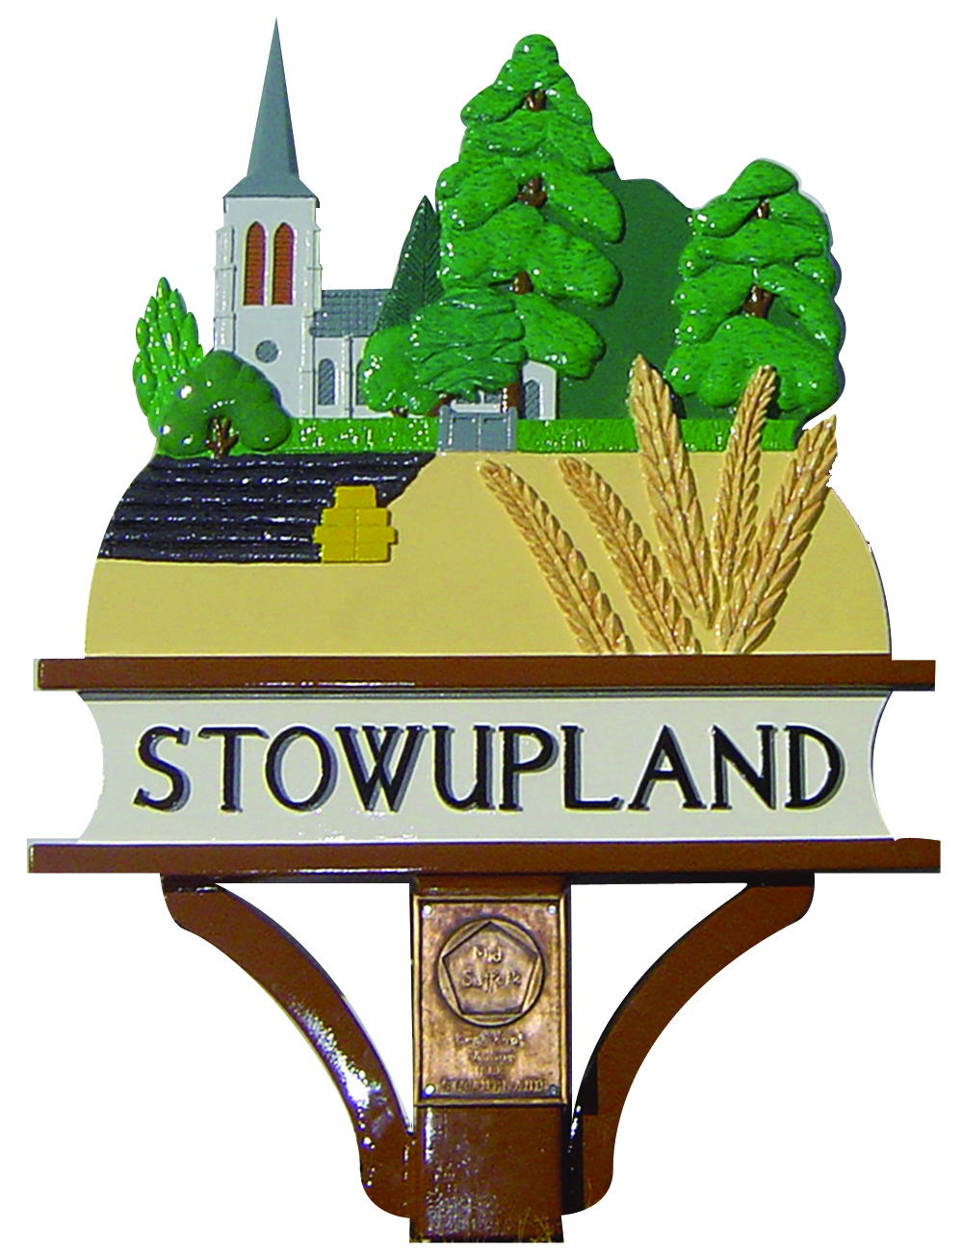

STOWUPLAND PARISH COUNCIL
2 Broomspath Road, Stowupland, Suffolk, IP14 4DB
Clerk: Claire Pizzey
01449 677005 (10am-noon Tuesdays-Thursdays)
clairepizzey@outlook.com

Policy relating to Thorney Green, Stowupland
Adopted 11 February 2016

- An individual that requests a deed of easement to an existing property (house/bungalow/business premises) or land will be advised that the applicant or their solicitor should write to the Parish Council proving that a right of way has been acquired. The Parish Council will then confirm that, providing there is no change of circumstance, the Parish Council will not deny access across the Green and a formal deed of easement is not required.

- If the applicant requests that the Parish Council give further consideration to the granting of a deed of easement, the applicant or their solicitor should write to the Parish Council proving that a right of way has been acquired. The letter should contain a map detailing the access for which the deed of easement is required and confirm that the applicant is prepared to meet all reasonable costs incurred by the Parish Council relating to the granting of the deed of easement. The Parish Council will consider each request on its merits and will make a charge to be based upon an expert valuation

- Any requests for new accesses to properties and land will be denied.

- Like for like repairs to existing accesses will be permitted.

- Any proposed changes to the surface of an existing access will require the prior approval of the Parish Council.

- Construction of new accesses or widening of existing accesses is not permitted.

- Permission will be granted for laying of or investigation of services across the Green. This may be subject to a charge. Any damage caused must be reinstated.

- Permission to be requested for temporary storage of materials/skips on the Green. Permission may be granted by the Parish Council (with conditions).

- Members of the Parish Council and public to be vigilant regarding any encroachment of the Green.

- No parking on the Green unless prior permission has been requested and obtained from the Parish Council.

- Vehicles at any property with a vehicular access shall park within the curtilage of that property. There shall be no overnight parking on accesses within the area of The Green. Parking for short periods on hardened accesses will be permitted. No parking will be permitted at any time on any grassed area without the written permission of the Parish Council.

On the first occurrence, a note will be placed on the windscreen of the vehicle explaining the policy. Should there be a re-occurrence involving the same vehicle (or another vehicle in the same location) the property owner and/or vehicle owner will be contacted and the police informed. If there is a further occurrence, the parish council will take appropriate action.

