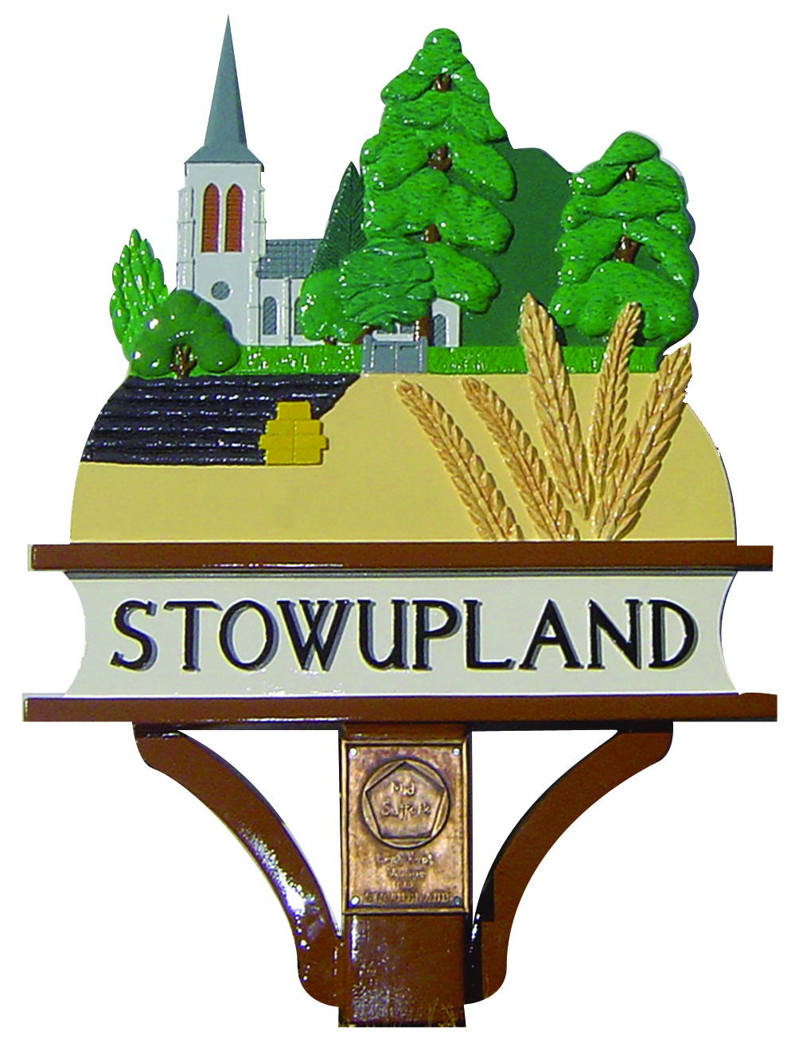

STOWUPLAND PARISH COUNCIL
2 Broomspath Road, Stowupland, Suffolk, IP14 4DB
Clerk: Claire Pizzey
01449 677005 (10am-noon Tuesdays-Thursdays)
clairepizzey@outlook.com

Equal Opportunities Statement
Adopted April 2014

LEGAL POSITION

It is unlawful to discriminate against an individual on the following grounds:

- age
- disability
- gender reassignment
- marriage and civil partnership
- pregnancy and maternity
- race
- religion or belief
- sex
- sexual orientation

Under the Equality Act 2010 these are known as “protected characteristics”.

PURPOSE
The purpose of this policy is to provide equal opportunities to all employees, irrespective of their characteristics (unless there are genuine occupational qualifications or objectively justified reasons for a different approach to be taken). We oppose all forms of unlawful and unfair discrimination whether it be direct or indirect discrimination, victimization or harassment on the grounds of any of the protected characteristics defined in the Equality Act 2010.

SCOPE
All employees whether full-time, part-time, fixed term contract, agency workers or temporary staff, will be treated fairly and equally. Selection for employment, promotion, training, remuneration or any other benefit will be on the basis of aptitude and ability. All employees will be helped and encouraged to develop their full potential and the talents and resources of the workforce will be fully utilised to maximise the efficiency of the council.

OUR COMMITMENT
Every employee is entitled to a working environment that promotes dignity and respect to all. No form of intimidation, bullying or harassment will be tolerated. This is further defined in the Dignity at Work policy adopted by the council.

The commitment to equal opportunities in the workplace is good management practice and makes sound business sense as it seeks to utilise the talents available from the local community, representing Society as a whole.

Breaches of our equal opportunities policy will be regarded as serious misconduct and could lead to disciplinary proceedings. Employees are entitled to complain about discrimination or harassment or victimization through the council’s Grievance procedure.

This policy is fully supported by all Members of the council.

The policy will be monitored and reviewed annually. Other Personnel policies will be reviewed against the values stated in this main Equal Opportunities policy to ensure that the council strives to remain an Equal Opportunities employer.

