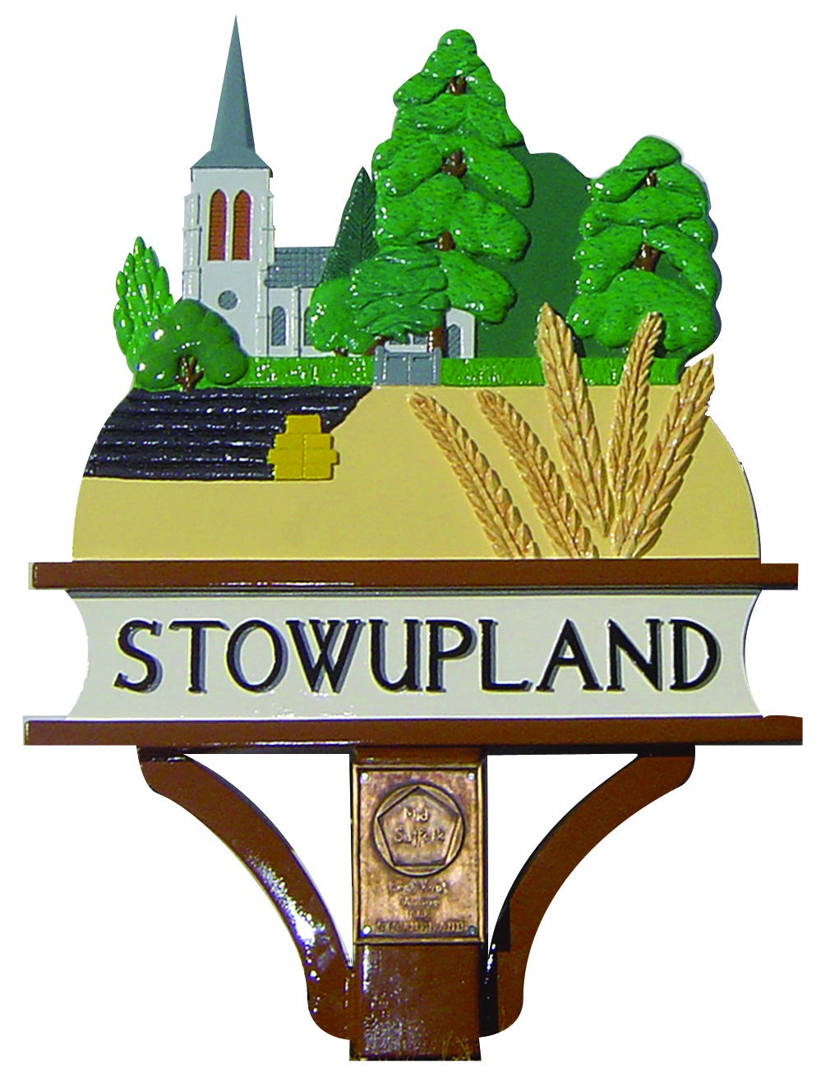

STOWUPLAND PARISH COUNCIL
2 Broomspath Road, Stowupland, Suffolk, IP14 4DB
Clerk: Claire Pizzey
01449 677005 (10am-noon Tuesdays-Thursdays)
parishclerk@stowuplandpc.co.uk

Committees, Sub-Committees and Working Groups 2018/19

 | Chair | Councillor | Non-Councillor
Committee
Finance and Policy | Cllr Laura Johnson | Cllrs, Dave Pring, Ray Studd, Jerry Voden and Keith Welham
Environment | Cllr Dave Pring | Cllrs, Roger Carter, Laura Johnson, Paula Murton and Ben Miller
Planning | Cllr Ray Studd | Cllrs, Laura Johnson, Dave Pring, Jerry Voden and Keith Welham
Sub-committees
Allotments | Cllr Keith Welham | Cllrs, Dave Pring and Jerry Voden
Cemetery and Churchyard | Cllr Sally Reeves | Cllrs, Roger Carter, Dave Pring | Jerry Doubtfire and Susan Hayter
Community Events | Cllr Hayden Guy | Cllrs, Sally Reeves, Jerry Voden and Keith Welham | Janet and Keith Hyland, Cathy Welham, Claire Pizzey, Paula Squires Sue Filby and Sarah Guy
Parish Infrastructure Improvement Plan (PIIP) | Cllr Keith Welham | Cllrs, Sally Reeves and Ray Studd
Advisory Sub-committees
Footpath Advisory | Cllr Paula Murton |  | Alan Bickerdike, Margaret Gough, Annie Bowen-Wright and Marion Harris
Neighbourhood Plan Advisory | Jackie Ward | Cllrs, Dave Pring, Ray Studd and Keith Welham | Debbie Balfour, Colin Board, Pat Hodgkins, Keith Hyland, Gill Jolly, Claire Pizzey, John Ryan, Margret Rose and Alan Wilkins
The Green | Cllr Dave Pring | Cllrs, Roger Carter, Laura Johnson, Ben Miller and Paula Murton
Transport, Traffic & Safety Advisory | Cllr Hayden Guy | Cllr Jerry Voden | Gordon Freeman, Keith Hyland, Albert Neilson and Dr Rose,
Working Groups
Play Park | Cllr Sally Reeves |  | Claire Pizzey
Outside Bodies
SALC | Cllr Jerry Voden
School Liaison | Cllr Keith Welham
Telstar | Cllrs Jerry Voden, Sally Reeves Keith Welham and Claire Pizzey
Tree Warden | Cllr Roger Carter
Village Hall | Cllr Jerry Voden

